https://www.seeedstudio.com/fusion_pcb.html
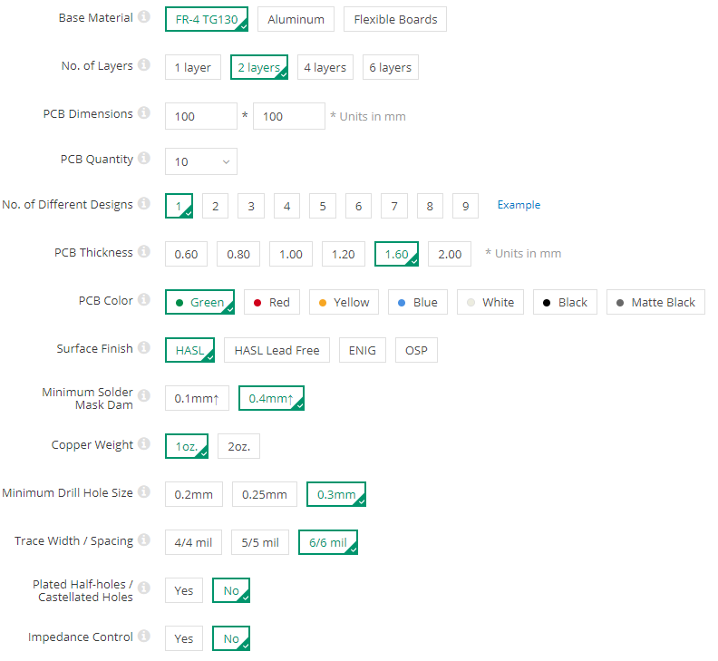
https://www.4pcb.com/trace-width-calculator.html

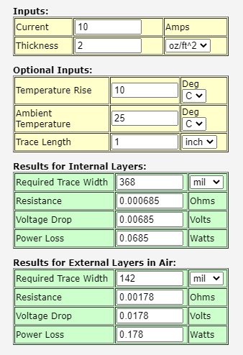

Base Material
FR-4 is the most commonly used material for PCBs. One sided aluminum boards have traces on one side and bare aluminium on the other. They are good for heat dissipation. For multi-layer aluminium PCBs please use the Advanced service. Flexible Printed Circuit boards (FPC) are much thinner than FR-4 and can be bent to some extent.
No. of Layers
The number of circuit layers in your boards. If you choose 1 layer, then the non-circuit side will not be covered with solder mask.
PCB Dimensions
The maximum length and width of your board or panel if the boards are panelised. Maximum and minimum lengths for FR-4 boards: 10 to 500mm. Aluminum boards: 10 to 450mm. Flexible boards: 10 to 230mm.
PCB Quantity
The number of boards/panels required. If your files are of a single board then this is the number of boards. If your boards are panelised into a panel, then this is the number of panels.
No. of Different Designs
How many different designs in your files separated by v-cuts, stamp holes or milling slots. Please see the example. Different designs are not accepted for multi-layer boards with over 6 circuit layers. Seeed does not provide panelisation services, if you want panelised boards, please design the panelised Gerber data yourself.
PCB Thickness
The final thickness of the finished PCBs. Board thickness tolerance is +/-10%. Solder mask and copper plating may make the boards slightly thicker.
PCB Color
The color of the solder mask applied onto the base material. For most colors, the silkscreen is printed white. Only for white solder mask, the silkscreen is printed black. No mixing of solder mask colors is allowed. Green solder mask has the best performance.
Surface Finish
HASL (Hot Air Solder Level) processing applies a thin layer of solder on the pads. ENIG (Electroless Nickel/Immersion Gold) has better planarity and shelf life than HASL. It is also lead free. Hard gold is useful for gold fingers or other hard wear areas. By selecting this option, the entire board will be plated in Hard Gold.
Minimum Solder Mask Dam
The minimum solder mask dam between copper pads. This helps to prevent accidental solder bridging during assembly. 0.1mm can only be achieved with green solder mask. If you choose black or white, the minimum solder mask dam is 0.15mm and for other colors the minimum is 0.12mm.
Copper Weight
Copper weight on the outer layers (top and bottom). The copper weight for inner layers is fixed at 0.5oz. If you need other weights please contact us directly or use the Advanced service.
Minimum Drill Hole Size
The minimum drill hole size required in the PCB. Drill hole sizes under 0.3mm are much more difficult to produce. For batch production please ensure hole size is more than 0.3mm.

Trace Width / Spacing
The minimum width of the traces and the minimum space between traces in your design. If your design needs to be batch produced, please ensure that the width and spacing is greater than 6 mil.
Plated Half-holes / Castellated Holes
Whether or not your boards require plated half-holes/castellated holes. These are holes on the edge of the board that require copper plating. This is a specialised process, we cannot v-cut or mill plated holes.
Impedance Control
Whether or not traces on the board need to meet impedance requirements. Please include impedance documentation in your upload. For more complex requirements, we may contact you for extra fees.
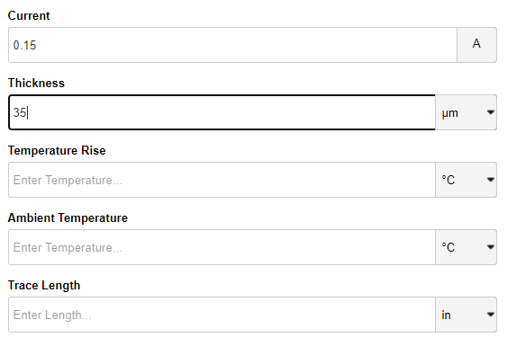
Trace thickness will be determined by the amount of copper (Copper Weight) on the PCB. Standard is 1 oz copper which gives a trace thickness of 35um. You can get heavier copper boards for higher prices, check with your PCB manufacturer. One way of decreasing trace resistance is by leaving off the soldermask and putting solder on top. Dave from the EEVBlog did some videos on it a couple of years ago.
https://www.digikey.com/en/resources/conversion-calculators/conversion-calculator-pcb-trace-width

Temperature rise – how hotter the PCB will be with the provided track parameters & current consumption.
1 mil (thousandth of an inch) = 0.0254 mm
Blind vias connect an exposed surface with an inner layer, but do not go through the entire board.
Buried vias connect inner layers with each other, and to not extend into the top or bottom layer.
Microvias are drilled with a laser instead of a regular drill bit, usually in a process step before the layers are laminated together.
Blind vias: connect an exterior layer to an interior layer
Buried vias: connect two interior layers
Through vias: connect two exterior layers
For a simple two-layer board, your only option is a through via. For boards with more than two layers, you might also be able to specify blind or buried vias in your design (at increased cost).
https://www.allaboutcircuits.com/technical-articles/which-via-should-i-choose-a-guide-to-vias-in-pcb-design/
A PCB "keepout area" is just as it sounds: it's an area that should be free of components and/or PCB traces. The term component includes any electrical, mechanical, or electro-mechanical device. And, keepout areas should be maintained under all application and environmental conditions

In KiCad the following layers are available.
- Layers that have a front and back version start with F. (for front) and B. (for back)
- The F.Cu and B.Cu layers are the copper layers
  - If there are additional copper layers they use the names In[number].Cu by default
  - The names for copper layers can be changed by the designer.
- F.Silk and B.Silk define artwork on the silkscreen layers.
  - Typically this is the white artwork printed on the board.
  - If there is space then it typically has a body outline, polarity marker and reference designator.
  - Be aware of minimum clearances to exposed copper and minimum line width requirements. (Resulting in minimum text size requirements.)
  - Small surface mount devices should not have silk below them as it can negatively impact the yield of the reflow process.
- F.Mask and B.Mask define the area free of soldermask 759.
  - It is the negative of the resulting film that covers the board.
  - More details see How does solder mask layer work? 19
- F.Paste and B.Paste define the area that will be covered with solder paste 373 (In datasheets often called stencil)
  - Used for reflow soldering 121 of surface mounted devices.
- Edge.cuts: This layer is used to communicate with the manufacturer what the final board shape should look like.
  - The edge-cut must not contain self intersections
  - Polygons on the edge-cut must be continuous and closed.
  - It is allowed to have internal cutouts
- F.Adhes and B.Adhes are layers to define adhesive (=glue) areas.
  - Only needed if components are on the bottom side during reflow soldering. (And even with components on the bottom it is not always needed. Check with your manufacturer if you need to define it for your board.)
- F.CrtYd and B.CrtYd are used to define a courtyard area.
  - The courtyard defines where no other component should be placed.
    - The size of this area depends on your manufacturing capabilities.
    - It also depends on your needs. (If you want the possibility to rework the pcb, you might need a larger area compared to when you do not plan to do this.)
    - The rules used in the official lib are defined in the KLC - Rule F5.3 224 and are closely aligned to industry standards.
  - This layer is checked for violations since version 5 of kicad.
    - KiCad requires every drawing on this layer to represent a closed polygon (drawn with the normal line drawing tool.)
    - Internal cutouts are allowed.
- F.Fab and B.Fab are documentation layers.
  - These are intended to be used for communicating with board assembly houses and for user documentation.
  - It typically has the outline of the part body (nominal or maximum dimensions, depends on your particular needs.)
  - It is common to have a polarity marker on this layer.
  - Reference and value fields are often found on this layer. (This might be the only place where these are found for high density boards as there is not enough space for silkscreen text. Fab text does not come with the same minimum size requirements as silk.)
- Dwgs.User and Cmts.User are used for user drawings and comments.
  - In the official lib this layer is used to communicate with the user of footprints. (Example to tell them where to place keepout areas as they are not directly supported by KiCad in footprints)
- Eco1 and Eco2 are layers with no specific defined purpose. (The user can use them for whatever they want. They are not used in footprints supplied by the official lib.)
- Margin layer: Is there to define a margin relative to the edge cut.
  - There is no DRC check to verify that no copper feature violates the margin definition.
https://forum.kicad.info/t/what-is-the-meaning-of-the-layers-in-pcb-new-and-in-the-footprint-editor-kicad-5-and-earlier/9688

The guides apply to four layer boards or less, for additional layers, please ensure that you export the necessary circuit layers.
For PCB orders, the following manufacturing files should be supplied together in a single .rar or .zip archive file. To import correctly into the Online Gerber Viewer, and to help us identify the layers, please manually change the extensions of your generated files to the ones listed below. If we cannot identify the layers we may contact you for confirmation.
Extension Layer
- pcbname.GTL Top Copper
- pcbname.GTS Top Soldermask
- pcbname.GTO Top Silkscreen
- pcbname.GBL Bottom copper
- pcbname.GBS Bottom Soldermask:
- pcbname.GBO Bottom Silkscreen:
- pcbname.TXT/DRL Drills
- pcbname.GML/GKO Board Outline
- pcbname.GL2 Inner Layer 2 (for ≥4 layers)
- pcbname.GL3 Inner Layer 3 (for ≥4 layers)
Notes:
- There must be a complete board outline in your files to show us how to cut out your boards. Ideally, this should be included in the mechanical layer and not only in the silkscreen layer. In some design software, you may be required to draw this yourself manually.
- Do not use non-ASCII characters in any file or folder names, this will prevent the files from importing into our CAM software..
Having problems generating the drill layer in Excellon format? If your design software does not have the option to generate the drill file in Excellon format, you can download CAM350 for free and convert it. For more information, click here.
For more information on how to place a PCB order, click here.
For information on the files required for Stencils, click here.
http://support.seeedstudio.com/knowledgebase/articles/1176532-how-to-generate-the-gerber-manufacturing-files

How to generate Gerber and drill files from KiCad
← How to generate PCB Gerber files?
In KiCad, open your PCB design file and go to File -> Plot, or find the plot icon on the main interface.
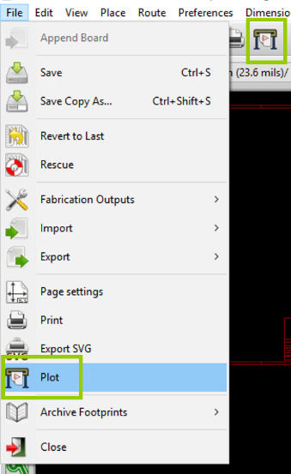
This will bring up the plot window. Select an output directory for your Gerber Files and select the following layers and options.
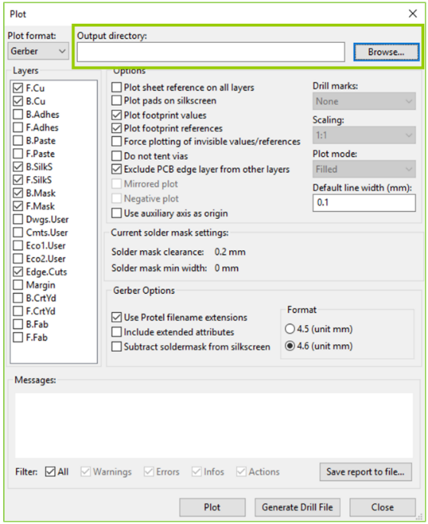
Please pay attention to the required layers, there should be 7 layers in total for typical two layer boards. If your boards are single or multi-layered, please select the necessary layers. Please note that all mechanical elements such as cut-outs and v-cuts should be drawn in the Edge.Cuts layer.

If you need the paste layers for stencil orders, please check B.Paste and F.Paste as required.

Also, please ensure that you do not select the Include extended attributes option under Gerber Options. This will effectively convert the format of your Gerber files to X2, which not all our equipment supports.
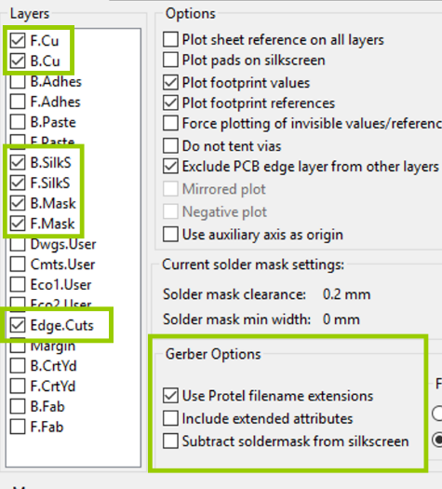
Click Plot and confirm that all the Gerber files were generated successfully.

To generate the drill files, select the Generate Drill File button and this will open a new window. Click Drill File on the right and this is will export the drill file in Excellon format in your chosen directory.

We suggest you select the option to Merge PTH and NPTH holes into one file, otherwise KiCad will separate plated and non-plated holes into two drill files, and if one is missing, there will be holes missing on your boards.
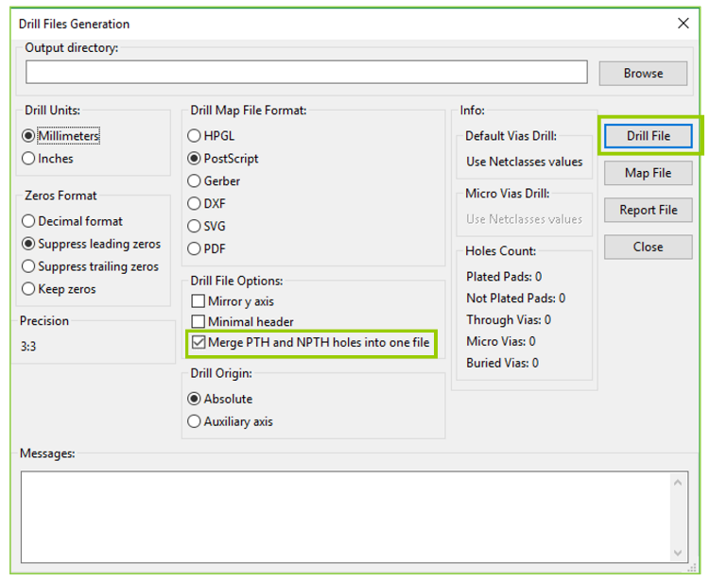
Please check that you have all 8 (or 9) files then zip them into a .zip or .rar archive file. You can use this to place the order on the Seeed Fusion PCB order page. We recommend that you give the files a quick check using the online Gerber Viewer before confirming the order.
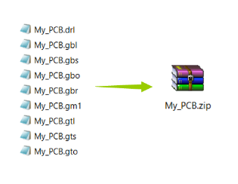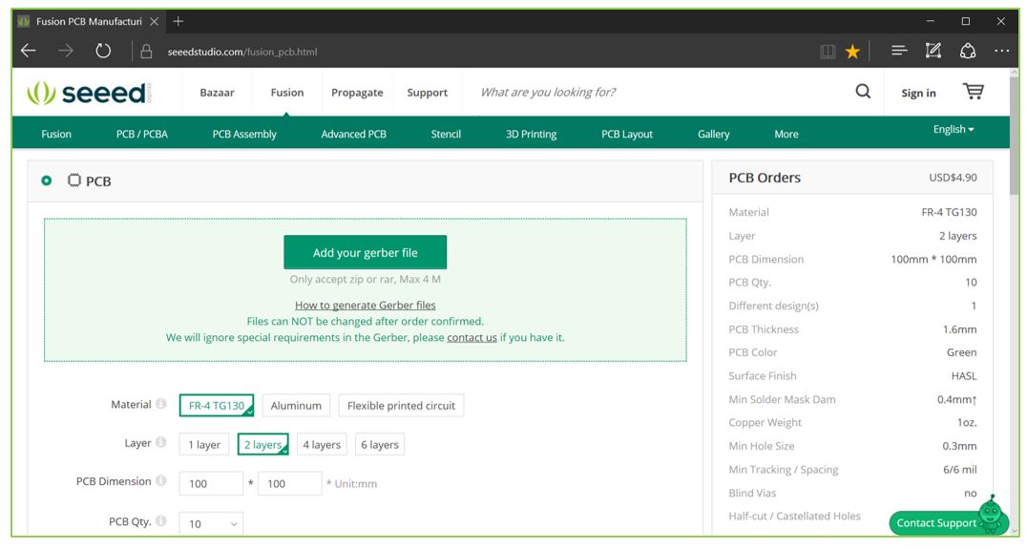

Common Mistakes and Problems:
- Incorrect Format: We prefer the Gerber files to be in RS-274x format over X2 since all our equipment are compatible with RS-274x. However, in standard versions of KiCad, it is not obvious whether the files are being exported in X2 or RS-274x format. In the Plot window, by selecting Include extended attributes, this converts the files into X2 format and cannot be imported into our standard CAM software. Please ensure you do not select this option.
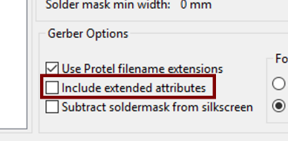
In some versions of KiCad, this is mentioned but please ensure that all X2 options are unchecked.
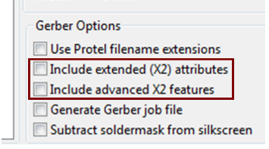
- Missing mechanical holes: Since KiCad has the option to export the plated and non-plated drill holes separately, it is easy to forget to include them both in the archive. If the PTH drill file is missing, this is easy to catch. But if the NPTH drill file for the mechanical holes is missing, it can be easy to overlook. To avoid this issue we suggest selecting the Merge PTH and NPTH holes into one file option.
- Drill holes do not match the rest of the layers in the Seeed Fusion Online Gerber Viewer: If the drill holes appear bunched up in one corner or are much larger than the other layers then this is likely caused by a mismatch in the drill file and Gerber file units. 99% of the time this will not affect our CAM engineers's ability to view the files correctly when sent for manufacture - they will change the units manually until they fit the Gerber files but the Online Gerber Viewer cannot do this. If you are experiencing this problem, changing the Zeroes Format during Drill File Generation will likely fix the problem. Decimal format is recommended for most cases.
Last Modified 2018/10/31

gm1/gml/gko extensions for board outline file

